

Practices for Secure Software Report

Table of Contents
Document Revision History 3
Client 3
Instructions 3
Developer 4
1. Algorithm Cipher 4
2. Certificate Generation 4
3. Deploy Cipher 4
4. Secure Communications 4
5. Secondary Testing 4
6. Functional Testing 4
7. Summary 4
8. Industry Standard Best Practices 4

Document Revision History

Version | Date | Author | Comments
1.0 | 4/25/2026 | Jacob Moore

Client



Instructions

Submit this completed practices for secure software report. Replace the bracketed text with the relevant information. You must document your process for writing secure communications and refactoring code that complies with software security testing protocols.

- Respond to the steps outlined below and include your findings.
- Respond using your own words. You may also choose to include images or supporting materials. If you include them, make certain to insert them in all the relevant locations in the document.
- Refer to the Project Two Guidelines and Rubric for more detailed instructions about each section of the template.

Developer
Jacob Moore

Algorithm Cipher

The algorithm I selected for this application is SHA-256, which is a cryptographic hash function used to ensure data integrity and security. SHA-256 produces a fixed 256 bit output regardless of the size of the input, making it very reliable for checksum verification. It is a one way function, meaning the original input cannot be derived from the hash output. SHA-256 is part of the SHA-2 family and is widely used in modern security systems due to its resistance to collision and brute force attacks. Older hashing algorithms such as MD5 and SHA-1 are no longer considered secure and have known vulnerabilities. Whereas SHA-256 is currently an industry standard hashing algorithm used in secure communications, digital signatures, and blockchain technologies. In this application SHA-256 is used to generate a checksum of a static string to verify data integrity during transmission.

Certificate Generation
Insert a screenshot below of the CER file.

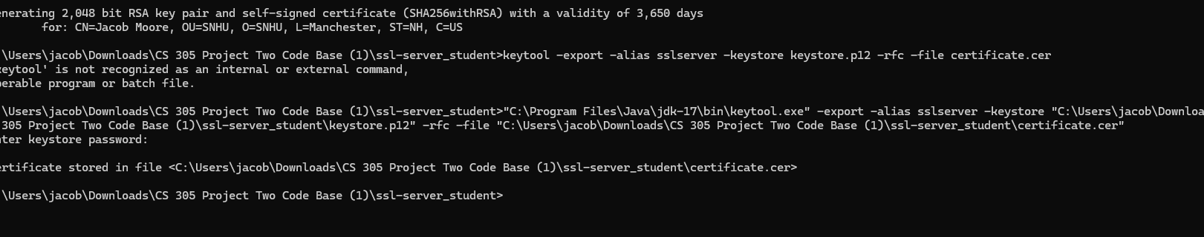
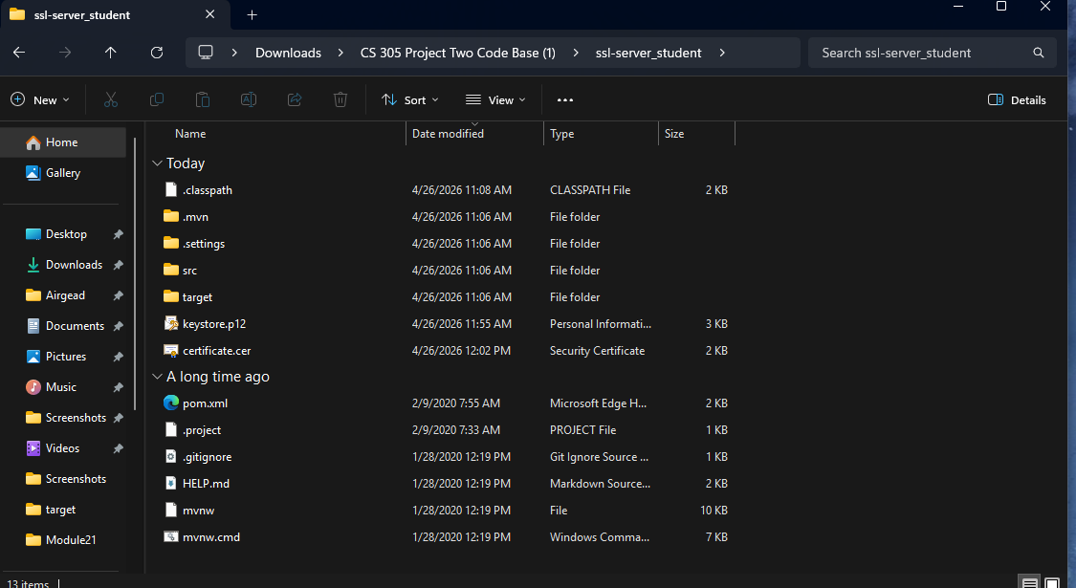

Deploy Cipher
Insert a screenshot below of the checksum verification.

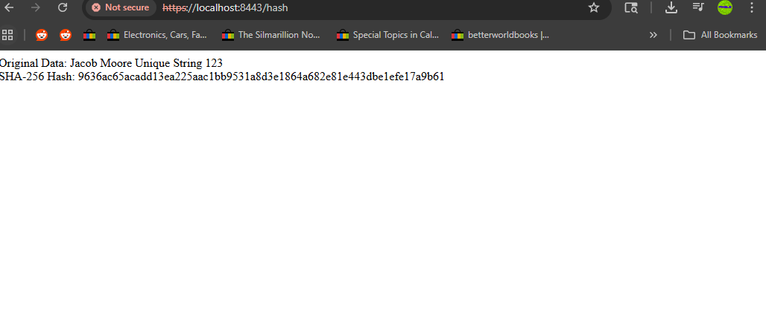

Secure Communications
Insert a screenshot below of the web browser that shows a secure webpage.



Secondary Testing
Insert screenshots below of the refactored code executed without errors and the dependency-check report.

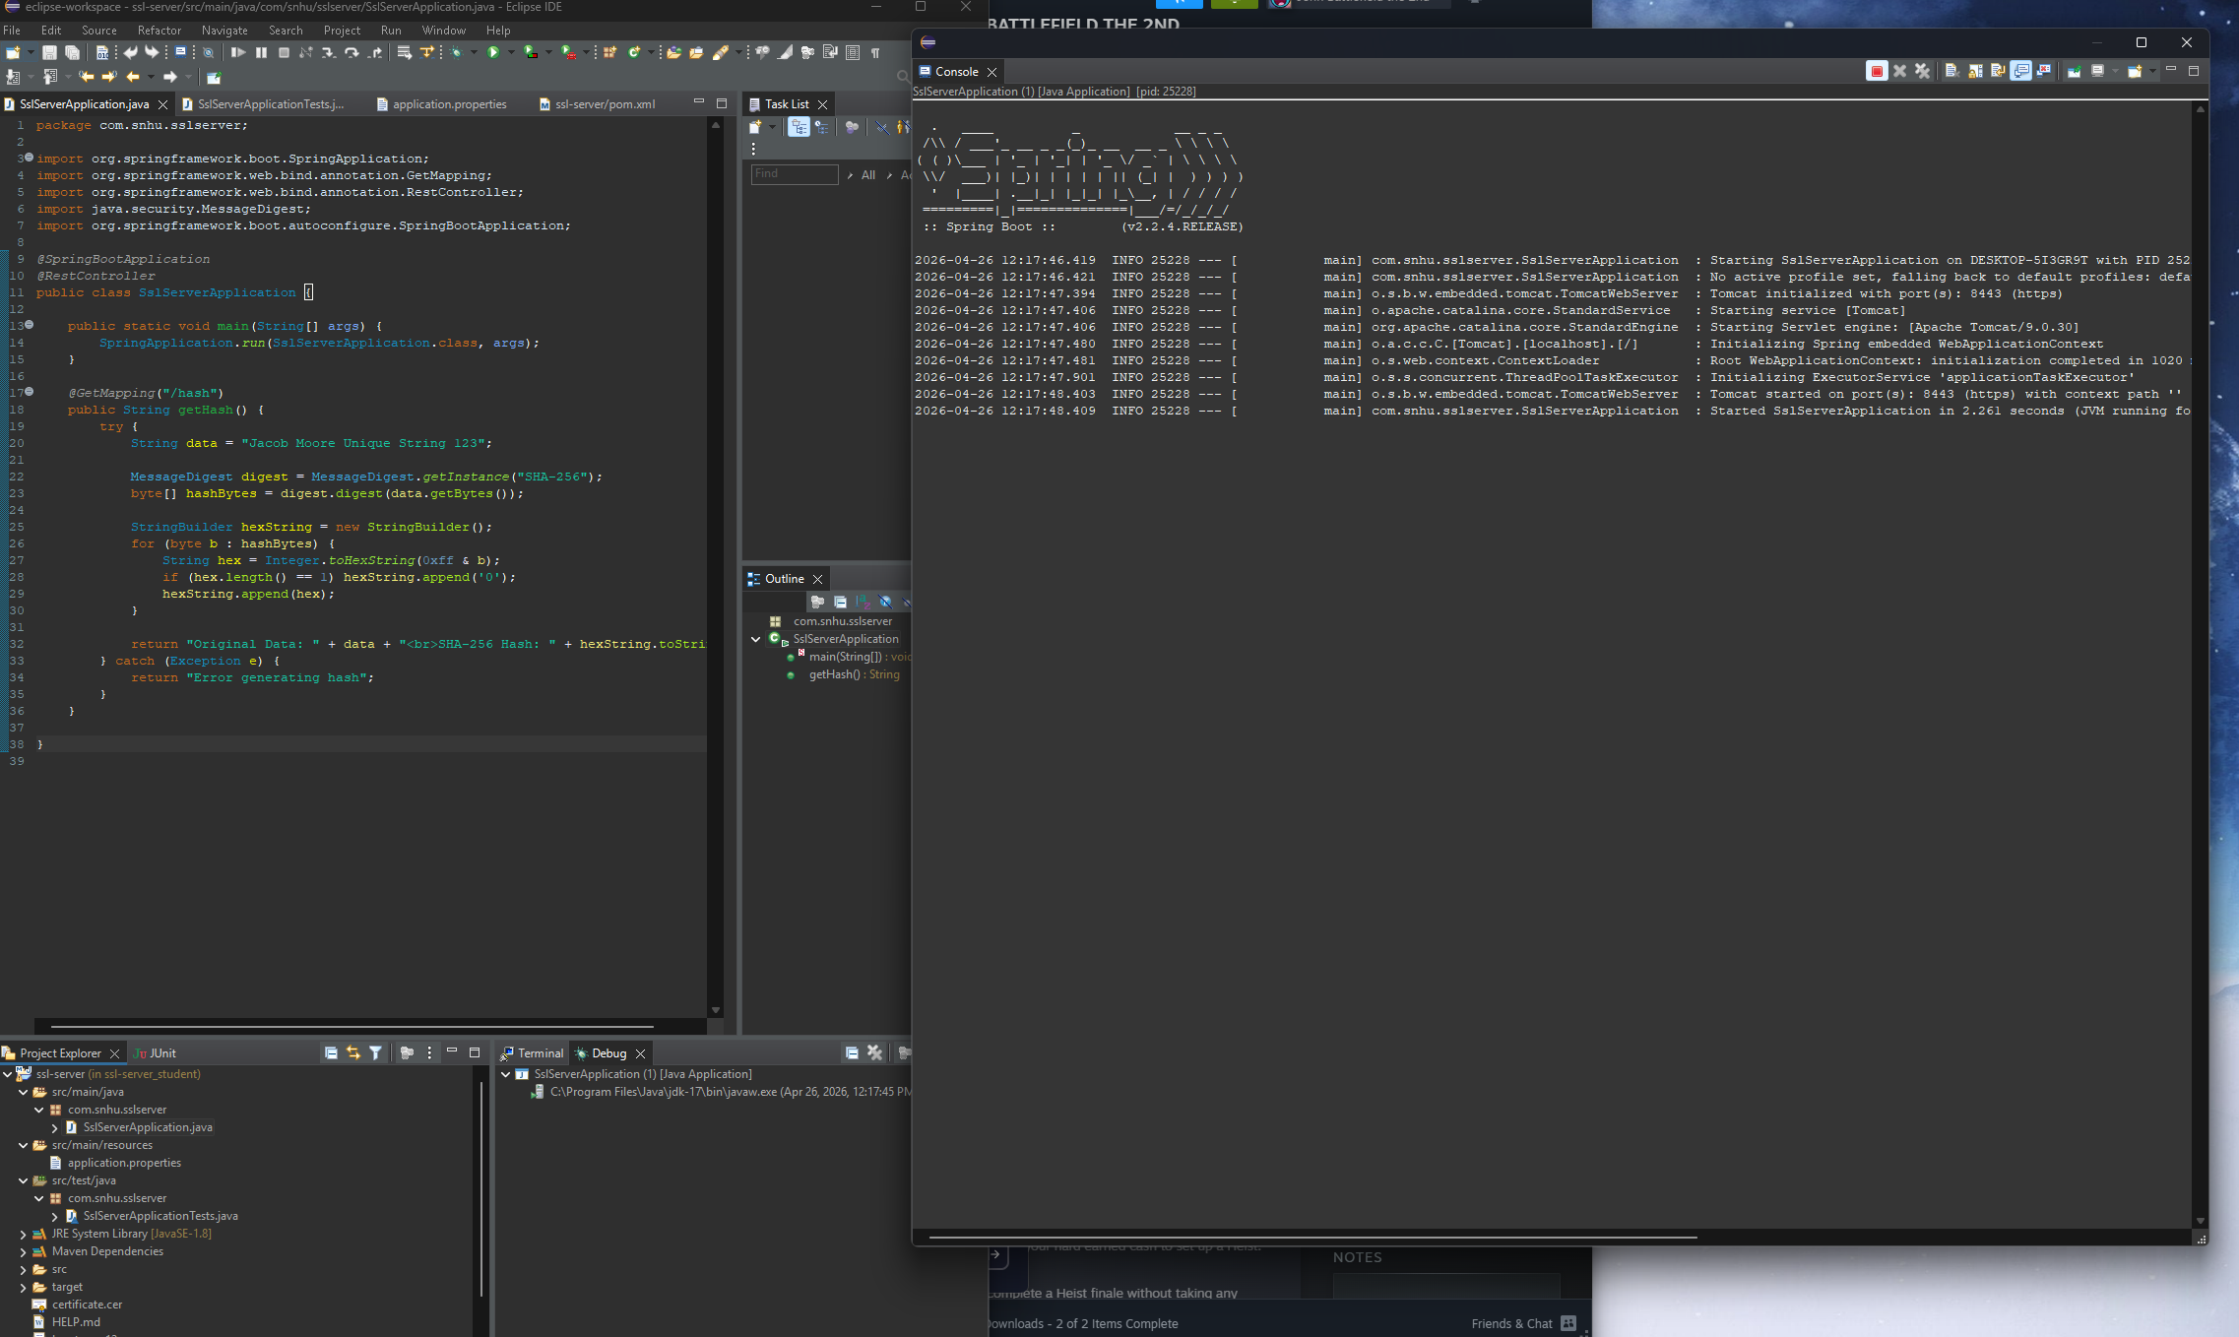
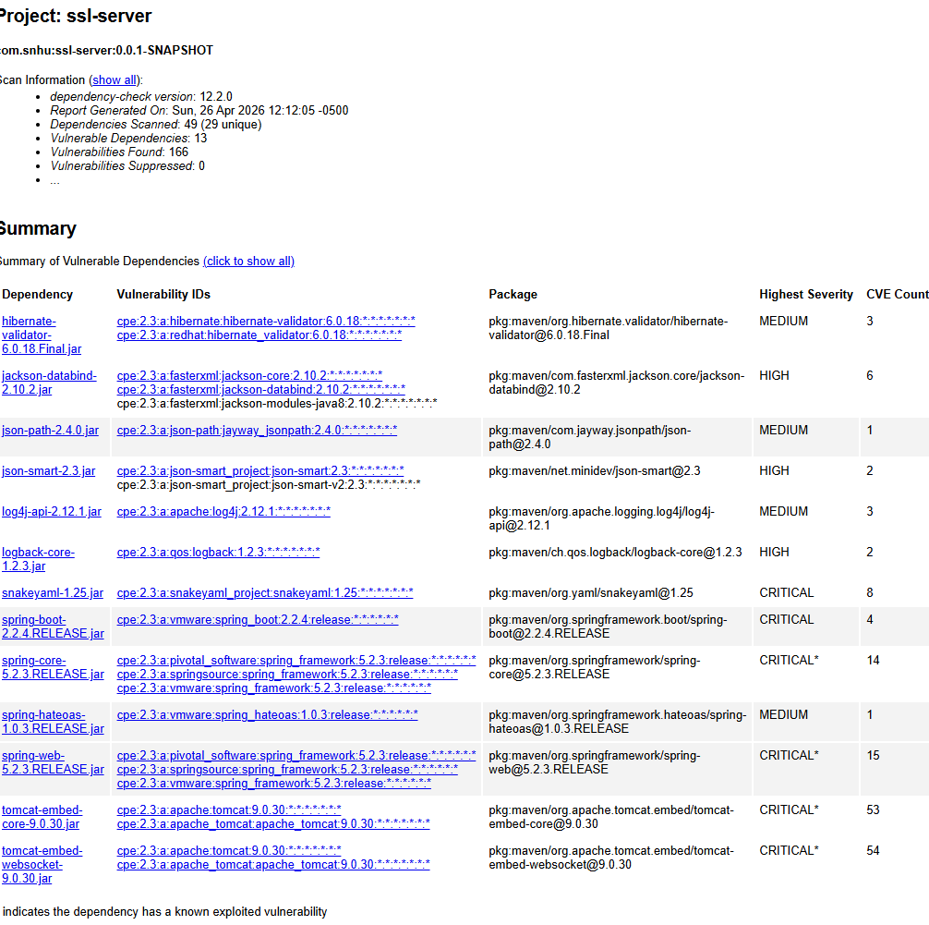

Functional Testing
Insert a screenshot below of the refactored code executed without errors.



Summary

The application was refactored to improve security by adding a SHA-256 checksum verification endpoint and enabling HTTPS communication using a self signed SSL certificate. The checksum ensures data integrity by generating a hash of a static string, which can be used to verify that data has not been altered. Secure communication was implemented by configuring Spring Boot to use SSL with a keystore file, converting the application from HTTP to HTTPS. This ensures that all data transmitted between the client and server is encrypted. Additionally, a dependency check scan was performed to verify that no new security vulnerabilities were introduced during refactoring. The application was tested to ensure it runs successfully without errors and meets the required security functionality.

Industry Standard Best Practices

I followed industry standard secure coding practices throughout my refactoring of the application. The SHA-256 hashing algorithm was used instead of an outdated and insecure algorithm such as MD5. This ensures string cryptographic protection for data integrity. HTTPS was implemented using SSL/TLS to encrypt communication between the client and server, protecting data in transit from interception or tampering. A self signed certificate was generated using the Java Keytool to enable secure communication in a development environment. Finally, I ran a dependency analysis using OWASP Dependency Check to identify and mitigate potential vulnerabilities in project dependencies. These practices improve the overall security of the application and align with modern secure software development standards.

